WCF Interview Questions
1) What is service host factory in WCF?
1. Service host factory is the mechanism by which we can create the instances of service host dynamically as the request comes in.
2. This is useful when we need to implement the event handlers for opening and closing the service.
3. WCF provides ServiceFactory class for this purpose.
2) What are tha advantages of hosting WCF service in WAS?
WAS (Windows Activation Service) is a component of IIS 7.0. Following are few advantages :
1. We are not only limited to HTTP protocol. We can also use supported protocols like TCP, named pipes and MSMQ
2. No need to completely install IIS. We can only install WAS component and keep away the WebServer.
3) In WCF which bindings supports the reliable session?
In WCF, following bindings supports the reliable session
1. wsHttpBinding
2. wsDualHttpBinding
3. wsFederationHttpBinding
4. netTcpBinding
4) What is Address Header in WCF?
Address Header contains the information which is sent with every request, it can be used by either end point service or any intermediate device for determining any routing logic or processing logic.
WCF provides AddressHeader class for this purpose.
Example :
AddressHeader addressHeader= AddressHeader.CreateAddressHeader("Name of the header", "Information included in header ");
Once the AddressHeader instance is created, it can be associated with end point instance as follows :
EndpointAddress endpoint = new EndpointAddress(new Uri("http://myserver/myservice"), addressHeader);
5) How to set the instancing mode in WCF service?
In WCF, instancing mode is set at service level. For ex.
//Setting PerSession instance mode
[ServiceBehavior(InstanceContextMode = InstanceContextMode.PerSession)]
class MyService : IMyService
{
//Implementation goes there
}
6) Which is the default mode for Instancing in WCF?
NOTE: This is objective type question, Please click question title for correct answer.
7) Which bindings in WCF support the message streaming?
Hello,
Following bindings supports the streaming in WCF:
1. basicHttpBinding
2. netTcpBinding
3. netNamedPipeBinding
8) Which are the 3 types of transactions manager WCF supports?
Hello,
WCF supports following 3 types of transactions managers:
a. LightWeight
b. OLE Transactions
c. WS-Atomic Transactions
9) How the concurrency mode is specified in WCF service?
Hello,
The concurrency mode is specified using the ServiceBehavior attribute on the class that implements the service.
Ex.
[ServiceBehavior(ConcurrencyMode=ConcurrencyMode.Single)]
Public class ServiceClass : IServiceInterface{
//Implementation Code
}
There are 3 possible values of ConcurrencyMode enumeration
Single
Reentrant
Multiple
10) What is ABC of WCF?
ABC is the three building blocks of WCF and they are known as
A - Address (Where): Address tells us where to find the services, like url
B - Bindings (How) : Bindings tells us how to find the services or using which protocols finds the services (SOAP, HTTP, TCT etc.)
C - Contacts (What): Contracts are an agreement between the consumer and the service providers that explains what parameters the service expects and what return values it gives.
Hope this will be very helpful to understand three building blocks of WCF, a very frequently asked interview questions.
11) Which protocol is used for platform-independent communication?
SOAP (Simple Object Access Protocol), which is directly supported from WCF (Windows Communication Foundation).
12) What is the purpose of base address in WCF service? How it is specified?
When multiple endpoints are associated with WCF service, base address (one primary address) is assigned to the service, and relative addresses are assigned to each endpoint. Base address is specified in <host> element for each service.
E.g.
<configuration>
<system.servicemodel>
<Services>
<service name=”MyService>
<host>
<baseAddresses>
<add baseAddress =”http://localhost:6070/MyService”>
</baseAddresses>
</host>
</service>
<services>
</system.servicemodel>
</configuration>
13) What is the difference between XMLSerializer and the DataContractSerializer?
a. DataContractSerializer is the default serializer fot the WCF
b. DataContractSerializer is very fast.
c. DataContractSerializer is basically for very small, simple subset of the XML infoset.
d. XMLSerializer is used for complex schemas.
14) What is Fault Contracts in WCF?
Fault Contracts is the way to handle exceptions in WCF. The problem with exceptions is that those are technology specific and therefore cannot be passed to other end because of interoperability issue. (Means either from Client to Server or vice-versa). There must be another way representing the exception to support the interoperability. And here the SOAP Faults comes into the picture.
Soap faults are not specific to any particular technology and they are based on industry standards.
To support SOAP Faults WCF provides FaultException class. This class has two forms:
a. FaultException : to send untyped fault back to consumer
b. FaultException<T>: to send typed fault data to the client
WCF service also provides FaultContract attribute so that developer can specify which fault can be sent by the operation (method). This attribute can be applied to operations only.
15) What is Message Contract in WCF?
Message Contract :
Message Contract is the way to control the SOAP messages, sent and received by the client and server.
Message Contract can be used to add and to get the custom headers in SOAP message
Because of Message Contract we can customize the parameters sent using SOAP message between the server and client.
16) What is DataContractSerializer in WCF?
DataContractSerializer is new WCF serializer.
This is serialization engine in WCF. DataContractSerializer translate the .NET framework objects into XML and vice-versa.
By default WCF uses DataContractSeriazer.
17) What are the various ways of hosting a WCF Service?
1.IIS
2.Self Hosting
3.WAS (Windows Activation Service)
18) What is XML Infoset?
The XML Information Set defines a data model for XML. It is an abstract set of concepts such as attributes and entities that can be used to describe a valid XML document. According to the specification, "An XML document's information set consists of a number of information items; the information set for any well-formed XML document will contain at least a document information item and several others."
19) What is .svc file in WCF?
.svc file is a text file. This file is similar to our .asmx file in web services.
This file contains the details required for WCF service to run it successfully.
This file contains following details :
1. Language (C# / VB)
2. Name of the service
3. Where the service code resides
Example of .svc file
<%@ ServiceHost Language="C#/VB" Debug="true/false" CodeBehind="Service code files path" Service="ServiceName"
We can also write our service code inside but this is not the best practice.
20) What is the Messaging Pattern? Which Messaging Pattern WCF supports?
Messaging Pattern : Messaging patterns describes how client and server should exchange the message. There is a protocol between client and server for sending and receiving the message. These are also called Message Exchange Pattern.
WCF supports following 3 types of Message Exchange Patterns
1. request - reply (default message exchange pattern)
2. OneWay (Simplex / datagram)
3. Duplex(CallBack)
21) Which is the default Message Exchange Pattern (MEP) ?
NOTE: This is objective type question, Please click question title for correct answer.
22) In WCF, Which contract is used to document the errors occurred in the service to client?
Fault Contract is used to document the errors occurred in the service to client.
23) Difference between Web Services and WCF?
Major Difference is That Web Services Use XmlSerializer But WCF Uses
DataContractSerializer which is better in Performance as Compared to XmlSerializer.
Key issues with XmlSerializer to serialize .NET types to XML
* Only Public fields or Properties of .NET types can be translated into XML.
* Only the classes which implement IEnumerable interface.
* Classes that implement the IDictionary interface, such as Hash table can not be serialized.
The DataContractAttribute can be applied to the class or a strcture. DataMemberAttribute can be applied to field or a property and theses fields or properties can be either public or private.
Important difference between DataContractSerializer and XMLSerializer.
* A practical benefit of the design of the DataContractSerializer is better performance over Xmlserializer.
* XML Serialization does not indicate the which fields or properties of the type are serialized into XML where as DataCotratSerializer Explicitly shows the which fields or properties are serialized into XML.
* The DataContractSerializer can translate the HashTable into XML.
24) Which namespace is required in a class to use DataContract or DataMember attribute for a class or properties?
NOTE: This is objective type question, Please click question title for correct answer.
25) What is the use of ServiceBehavior attribute in WCF ?
ServiceBehaviour attribute is used to specify the InstanceContextMode for the WCF Service class (This can be used to maintained a state of the service or a client too)
There are three instance Context Mode in the WFC
PerSession : This is used to create a new instance for a service and the same instance is used for all method for a particular client. (eg: State can be maintained per session by declaring a variable)
PerCall : This is used to create a new instance for every call from the client whether same client or different. (eg: No state can be maintained as every time a new instance of the service is created)
Single : This is used to create only one instance of the service and the same instance is used for all the client request. (eg: Global state can be maintained but this will be applicable for all clients)
26) What is a SOA Service?
SOA is Service Oriented Architecture. SOA service is the encapsulation of a high level business concept. A SOA service is composed of three parts.
1. A service class implementing the service to be provided.
2. An environment to host the service.
3. One or more endpoints to which clients will connect.
27) Which namespace is used to access WCF service?
NOTE: This is objective type question, Please click question title for correct answer.
28) What is WCF?
Answer edited by Webmaster
Windows Communication Foundation (WCF) is an SDK for developing and deploying services on Windows. WCF provides a runtime environment for services, enabling you to expose CLR types as services, and to consume other services as CLR types.
WCF is part of .NET 3.0 and requires .NET 2.0, so it can only run on systems that support it.
(content from another post: http://www.dotnetfunda.com/interview/exam283-what-is-wcf.aspx)
29) Difference between WCF and Web services?
Web Services
1.It Can be accessed only over HTTP
2.It works in stateless environment
WCF
WCF is flexible because its services can be hosted in different types of applications. The following lists several common scenarios for hosting WCF services:
IIS
WAS
Self-hosting
Managed Windows Service
30) What are the various ways of hosting a WCF service?
Self hosting the service in his own application domain. This we have already covered in the first section. The service comes in to existence when you create the object of ServiceHost class and the service closes when you call the Close of the ServiceHost class.
Host in application domain or process provided by IIS Server.
Host in Application domain and process provided by WAS (Windows Activation Service) Server.
31) What is three major points in WCF?
We Should remember ABC.
Address --- Specifies the location of the service which will be like http://Myserver/MyService.Clients will use this location to communicate with our service.
Binding --- Specifies how the two paries will communicate in term of transport and encoding and protocols
Contract --- Specifies the interface between client and the server.It's a simple interface with some attribute.
32) What is the difference WCF and Web services?
Web services can only be invoked by HTTP (traditional webservice with .asmx). While WCF Service or a WCF component can be invoked by any protocol (like http, tcp etc.) and any transport type.
Second web services are not flexible. However, WCF Services are flexible. If you make a new version of the service then you need to just expose a new end. Therefore, services are agile and which is a very practical approach looking at the current business trends.
We develop WCF as contracts, interface, operations, and data contracts. As the developer we are more focused on the business logic services and need not worry about channel stack. WCF is a unified programming API for any kind of services so we create the service and use configuration information to set up the communication mechanism like HTTP/TCP/MSMQ etc
For more details, read http://msdn.microsoft.com/en-us/library/aa738737.aspx
33) What are various ways of hosting WCF Services?
There are three major ways of hosting a WCF services
• Self-hosting the service in his own application domain. This we have already covered in the first section. The service comes in to existence when you create the object of Service Host class and the service closes when you call the Close of the Service Host class.
• Host in application domain or process provided by IIS Server.
• Host in Application domain and process provided by WAS (Windows Activation Service) Server.
More details http://www.dotnetfunda.com/articles/article221.aspx#whatarethevariouswaysofhostingaWCFservice
34) What are the main components of WCF?
The main components of WCF are
1. Service class
2. Hosting environment
3. End point
For more details read http://www.dotnetfunda.com/articles/article221.aspx#WhatarethemaincomponentsofWCF
35) What was the code name for WCF?
The code name of WCF was Indigo .
WCF is a unification of .NET framework communication technologies which unites the following technologies:-
NET remoting
MSMQ
Web services
COM+
36) How to deal with operation overloading while exposing the WCF services?
By default overload operations (methods) are not supported in WSDL based operation. However by using Name property of OperationContract attribute, we can deal with operation overloading scenario.
[ServiceContract]
interface ICalculator
{
[OperationContract(Name = "AddInt")]
int Add(int arg1,int arg2);
[OperationContract(Name = "AddDouble")]
double Add(double arg1,double arg2);
}
37) How to set the timeout property for the WCF Service client call?
The timeout property can be set for the WCF Service client call using binding tag.
<client>
<endpoint
...
binding = "wsHttpBinding"
bindingConfiguration = "LongTimeout"
...
/>
</client>
<bindings>
<wsHttpBinding>
<binding name = "LongTimeout" sendTimeout = "00:04:00"/>
</wsHttpBinding>
</bindings>
If no timeout has been specified, the default is considered as 1 minute.
38) How to configure Reliability while communicating with WCF Services?
Reliability can be configured in the client config file by adding reliableSession under binding tag.
<system.serviceModel>
<services>
<service name = "MyService">
<endpoint
address = "net.tcp://localhost:8888/MyService"
binding = "netTcpBinding"
bindingConfiguration = "ReliableCommunication"
contract = "IMyContract"
/>
</service>
</services>
<bindings>
<netTcpBinding>
<binding name = "ReliableCommunication">
<reliableSession enabled = "true"/>
</binding>
</netTcpBinding>
</bindings>
</system.serviceModel>
Reliability is supported by following bindings only
NetTcpBinding
WSHttpBinding
WSFederationHttpBinding
WSDualHttpBinding
39) What is Transport and Message Reliability?
Transport reliability (such as the one offered by TCP) offers point-to-point guaranteed delivery at the network packet level, as well as guarantees the order of the packets. Transport reliability is not resilient to dropping network connections and a variety of other communication problems.
Message reliability deals with reliability at the message level independent of how many packets are required to deliver the message. Message reliability provides for end-to-end guaranteed delivery and order of messages, regardless of how many intermediaries are involved, and how many network hops are required to deliver the message from the client to the service.
40) What are different elements of WCF Srevices Client configuration file?
WCF Services client configuration file contains endpoint, address, binding and contract. A sample client config file looks like
<system.serviceModel>
<client>
<endpoint name = "MyEndpoint"
address = "http://localhost:8000/MyService/"
binding = "wsHttpBinding"
contract = "IMyContract"
/>
</client>
</system.serviceModel>
41) What is Proxy and how to generate proxy for WCF Services?
The proxy is a CLR class that exposes a single CLR interface representing the service contract. The proxy provides the same operations as service's contract, but also has additional methods for managing the proxy life cycle and the connection to the service. The proxy completely encapsulates every aspect of the service: its location, its implementation technology and runtime platform, and the communication transport.
The proxy can be generated using Visual Studio by right clicking Reference and clicking on Add Service Reference. This brings up the Add Service Reference dialog box, where you need to supply the base address of the service (or a base address and a MEX URI) and the namespace to contain the proxy.
Proxy can also be generated by using SvcUtil.exe command-line utility. We need to provide SvcUtil with the HTTP-GET address or the metadata exchange endpoint address and, optionally, with a proxy filename. The default proxy filename is output.cs but you can also use the /out switch to indicate a different name.
SvcUtil http://localhost/MyService/MyService.svc /out:Proxy.cs
When we are hosting in IIS and selecting a port other than port 80 (such as port 88), we must provide that port number as part of the base address:
SvcUtil http://localhost:88/MyService/MyService.svc /out:Proxy.cs
42) What is the address formats of the WCF transport schemas?
Address format of WCF transport schema always follow
[transport]://[machine or domain][:optional port] format.
for example:
HTTP Address Format
http://localhost:8888
the way to read the above url is
"Using HTTP, go to the machine called localhost, where on port 8888 someone is waiting"
When the port number is not specified, the default port is 80.
TCP Address Format
net.tcp://localhost:8888/MyService
When a port number is not specified, the default port is 808:
net.tcp://localhost/MyService
NOTE: Two HTTP and TCP addresses from the same host can share a port, even on the same machine.
IPC Address Format
net.pipe://localhost/MyPipe
We can only open a named pipe once per machine, and therefore it is not possible for two named pipe addresses to share a pipe name on the same machine.
MSMQ Address Format
net.msmq://localhost/private/MyService
net.msmq://localhost/MyService
43) How to define a service as REST based service in WCF?
WCF 3.5 provides explicit support for RESTful communication using a new binding named WebHttpBinding.
The below code shows how to expose a RESTful service
[ServiceContract]
interface IStock
{
[OperationContract]
[WebGet]
int GetStock(string StockId);
}
By adding the WebGetAttribute, we can define a service as REST based service that can be accessible using HTTP GET operation.
44) What is endpoint in WCF?
Every service must have Address that defines where the service resides, Contract that defines what the service does and a Binding that defines how to communicate with the service. In WCF the relationship between Address, Contract and Binding is called Endpoint.
The Endpoint is the fusion of Address, Contract and Binding.
45) What is binding and how many types of bindings are there in WCF?
A binding defines how an endpoint communicates to the world. A binding defines the transport (such as HTTP or TCP) and the encoding being used (such as text or binary). A binding can contain binding elements that specify details like the security mechanisms used to secure messages, or the message pattern used by an endpoint.
WCF supports nine types of bindings.
Basic binding
Offered by the BasicHttpBinding class, this is designed to expose a WCF service as a legacy ASMX web service, so that old clients can work with new services. When used by the client, this binding enables new WCF clients to work with old ASMX services.
TCP binding
Offered by the NetTcpBinding class, this uses TCP for cross-machine communication on the intranet. It supports a variety of features, including reliability, transactions, and security, and is optimized for WCF-to-WCF communication. As a result, it requires both the client and the service to use WCF.
Peer network binding
Offered by the NetPeerTcpBinding class, this uses peer networking as a transport. The peer network-enabled client and services all subscribe to the same grid and broadcast messages to it.
IPC binding
Offered by the NetNamedPipeBinding class, this uses named pipes as a transport for same-machine communication. It is the most secure binding since it cannot accept calls from outside the machine and it supports a variety of features similar to the TCP binding.
Web Service (WS) binding
Offered by the WSHttpBinding class, this uses HTTP or HTTPS for transport, and is designed to offer a variety of features such as reliability, transactions, and security over the Internet.
Federated WS binding
Offered by the WSFederationHttpBinding class, this is a specialization of the WS binding, offering support for federated security.
Duplex WS binding
Offered by the WSDualHttpBinding class, this is similar to the WS binding except it also supports bidirectional communication from the service to the client.
MSMQ binding
Offered by the NetMsmqBinding class, this uses MSMQ for transport and is designed to offer support for disconnected queued calls.
MSMQ integration binding
Offered by the MsmqIntegrationBinding class, this converts WCF messages to and from MSMQ messages, and is designed to interoperate with legacy MSMQ clients.
For WCF binding comparison, see http://www.pluralsight.com/community/blogs/aaron/archive/2007/03/22/46560.aspx
46) Where we can host WCF services?
Every WCF services must be hosted somewhere. There are three ways of hosting WCF services.
They are
1. IIS
2. Self Hosting
3. WAS (Windows Activation Service)
For more details see http://msdn.microsoft.com/en-us/library/bb332338.aspx
47) What are contracts in WCF?
In WCF, all services expose contracts. The contract is a platform-neutral and standard way of describing what the service does.
WCF defines four types of contracts.
Service contracts
Describe which operations the client can perform on the service.
There are two types of Service Contracts.
ServiceContract - This attribute is used to define the Interface.
OperationContract - This attribute is used to define the method inside Interface.
[ServiceContract]
interface IMyContract
{
[OperationContract]
string MyMethod( );
}
class MyService : IMyContract
{
public string MyMethod( )
{
return "Hello World";
}
}
Data contracts
Define which data types are passed to and from the service. WCF defines implicit contracts for built-in types such as int and string, but we can easily define explicit opt-in data contracts for custom types.
There are two types of Data Contracts.
DataContract - attribute used to define the class
DataMember - attribute used to define the properties.
[DataContract]
class Contact
{
[DataMember]
public string FirstName;
[DataMember]
public string LastName;
}
If DataMember attributes are not specified for a properties in the class, that property can't be passed to-from web service.
Fault contracts
Define which errors are raised by the service, and how the service handles and propagates errors to its clients.
Message contracts
Allow the service to interact directly with messages. Message contracts can be typed or untyped, and are useful in interoperability cases and when there is an existing message format we have to comply with.
48) What is address in WCF and how many types of transport schemas are there in WCF?
Address is a way of letting client know that where a service is located. In WCF, every service is associated with a unique address. This contains the location of the service and transport schemas.
WCF supports following transport schemas
HTTP
TCP
Peer network
IPC (Inter-Process Communication over named pipes)
MSMQ
The sample address for above transport schema may look like
http://localhost:81
http://localhost:81/MyService
net.tcp://localhost:82/MyService
net.pipe://localhost/MyPipeService
net.msmq://localhost/private/MyMsMqService
net.msmq://localhost/MyMsMqService
49) What is service and client in perspective of data communication?
Posted by: Poster
A service is a unit of functionality exposed to the world.
The client of a service is merely the party consuming the service.
50) What is WCF?
Windows Communication Foundation (WCF) is an SDK for developing and deploying services on Windows. WCF provides a runtime environment for services, enabling you to expose CLR types as services, and to consume other services as CLR types.
WCF is part of .NET 3.0 and requires .NET 2.0, so it can only run on systems that support it.
51) What is a service level message and transport level message?
You can log WCF message at two levels one is service level and the other is transport level. Service level:-In this the messages are logged as they enter the user code or leave the user code. Transport level: - In this the messages are logged as they are ready to be encoded / decoded. All transport level, infrastructure messages and also reliable messaging is logged. You specify the message levels in the diagnostics node as shown in the below code snippet.
<system.serviceModel>
<diagnostics>
<messageLogging
logEntireMessage="true"
logMalformedMessages="false"
logMessagesAtServiceLevel="false"
logMessagesAtTransportLevel="true"
maxMessagesToLog="3000"
maxSizeOfMessageToLog="10000"/>
</diagnostics>
</system.serviceModel>
‘Messagelogging’ also has other attributes , below is the short description about the same.
Attribute | Description
logEntireMessage | Should the entire message be logged on only the header.
logMalformedMessages | Should malformed messages be logged.
logMessagesAtServiceLevel | Should service-level messages be logged.
logMessagesAtTransportLevel | Should transport level messages be logged.
maxMessageToLog | Number indicating how many messages should be logged.
maxSizeOfMessageToLog | The default value is 256Kb. Max size of the message log.
52) What is the concept of tracelevel in trace listeners?
In the previous question we have specified switch value as information. This value indicates what type and level of tracing information you want to record. Below is the list of the same.
Trace Level | Description
Off | Ignore all trace messages
Critical | Log unexpected processing events or unhandled exceptions have occurred. The application will terminate immediately or shortly.
Error | An unexpected processing event or exception has occurred. The application is still capable of continuing its processing.
Warning | Indicates there is a possible problem but the application will continue running.
Information | Application is running smoothly only that informative message is recorded. In this case messages are just milestones.
Verbose | Very similar to information but provides more details as compared.
ActivityTracing | In this case messages are related to communication between components and the activities.
All | In this case all messages are captured.
Trace level value is specified in ‘source’ tag in switch value. For instance the below ‘web.config’ snippet indicates the trace type as ‘Information’.
<system.diagnostics>
<sources>
<source name="System.ServiceModel"
switchValue="Information, ActivityTracing">
............
............
............
............
53) How can we enable tracing on the readymade tracing WCF objects?
We will enable tracing on ‘System.ServiceModel’ tracing object. To enable tracing we need to enable the ‘system.diagnostics’ XML node in the ‘web.config’ file of the WCF service. We need to also define the type of listeners for the ‘System.ServiceModel’ listener object. So we add the ‘listeners’ tag with the type as ‘System.Diagnostics.XmlWriterTraceListener’. We need to also define the file and path where the file is created. For the current scenario we have defined the file as ‘Traces.svclog’ and the folder as ‘c:\’ drive.
<system.diagnostics>
<sources>
<source name="System.ServiceModel"
switchValue="Information, ActivityTracing">
<listeners>
<add name="log"
type="System.Diagnostics.XmlWriterTraceListener"
initializeData="c:\Traces.svclog" />
</listeners>
</source>
</sources>
</system.diagnostics>
Now if you run the WCF service you can see a XML file created as shown below.
#<E2ETraceEvent xmlns="http://schemas.microsoft.com/2004/06/E2ETraceEvent">
<System xmlns="http://schemas.microsoft.com/2004/06/windows/eventlog/system">
<EventID>0</EventID>
<Type>3</Type>
<SubType Name="Transfer">0</SubType>
<Level>255</Level>
<TimeCreated SystemTime="2009-04-30T03:21:09.5625000Z" />
<Source Name="System.ServiceModel" />
<Correlation ActivityID="{00000000-0000-0000-0000-000000000000}" RelatedActivityID="{d11829b7-d2db-46d5-a4ac-49a37a56376e}" />
<Execution ProcessName="WebDev.WebServer" ProcessID="2660" ThreadID="8" />
<Channel/>
<Computer>COMPAQ-JZP37MD0</Computer>
</System>
<ApplicationData></ApplicationData>
</E2ETraceEvent>

54) What are the readymade trace events and they are available for which WCF objects ?
You can always use the core ‘Tracelistener’ events provided by .NET , but WCF has readymade trace listeners for the core WCF objects.
Assembly Name | Description
System.ServiceModel | Logs the following :-  Message process  Reading of configuration information  Transport-level action  Security requests
System.ServiceModel.MessageLogging | Generates tracing information for every message that flows through the system.
System.ServiceModel.IdentityModel | Generate trace data for authentication and authorization.
System.ServiceModel.Activation | Emits information regarding activation of the service.
System.Runtime.Serialization | Emits information when objects are serialized or deserialized. WCF always serializes and de-serializes information during request so it’s a good event to see the content of the request.
System.IO.Log | Emits messages with respect to Common Log File System (CLFS).
CardSpace | Emits trace messages related to any CardSpace identity processing that occurs within WCF context.

55) Can you explain the concept of trace listener?
‘Tracelistener’ are objects that get tracing information from the trace class and they output the data to some medium. For instance you can see from the figure ‘TraceListener’ how it listens to the trace object and outputs the same to UI, File or a windows event log. There are three different types of ‘tracelistener’ first is the ‘defaulttracelistener’ (this outputs the data to UI), second is ‘textwritertracelistener’ (this outputs to a file) and the final one is ‘Eventlogtracelistener’ which outputs the same to a windows event log.
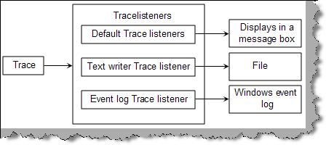
Figure – TraceListener
Below is a code snippet for ‘textwritertracelistener’ and ‘eventlogtracelistener’. Using ‘textwritertracelistener’ we have forwarded the trace’s to ‘ErrorLog.txt’ file and in the second snippet we have used the ‘Eventlogtracelistener’ to forward the trace’s to windows event log.
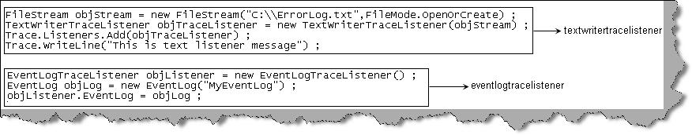
Figure:- Tracelistener in action
56) Can you show the security differences between BasicHttpBinding VS WsHttpBinding ?
In order to understand the security differences between both these entities we will do a small project. In this project we will create two WCF service one service using ‘BasicHttpBinding’ and the second service using ‘WsHttpBinding’.

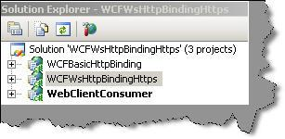

Step1:- So let’s first create a simple service using ‘BasicHttpBinding’. For that we just a create a simple WCF project and then modify the ‘ServiceModel’ element as shown below. You can see in the ‘endpoint’ tag we have specified ‘basicHttpBinding’ as the protocol.
<system.serviceModel>
<services>
<service name="WCFBasicHttpBinding.Service1" behaviorConfiguration="WCFBasicHttpBinding.Service1Behavior">
<!-- Service Endpoints -->
<endpoint address="" binding="basicHttpBinding" contract="WCFBasicHttpBinding.IService1">
<!—
Upon deployment, the following identity element should be removed or replaced to reflect the
identity under which the deployed service runs. If removed, WCF will infer an appropriate identity
automatically.
-->
<identity>
<dns value="localhost"/>
</identity>
</endpoint>
<endpoint address="mex" binding="mexHttpBinding" contract="IMetadataExchange"/>
</service>
</services>
<behaviors>
<serviceBehaviors>
<behavior name="WCFBasicHttpBinding.Service1Behavior">
<!-- To avoid disclosing metadata information, set the value below to false and remove the metadata endpoint above before deployment -->
<serviceMetadata httpGetEnabled="true"/>
<!-- To receive exception details in faults for debugging purposes, set the value below to true. Set to false before deployment to avoid disclosing exception information -->
<serviceDebug includeExceptionDetailInFaults="false"/>
</behavior>
</serviceBehaviors>
</behaviors>
</system.serviceModel>
Step 2 :- We also need to create one more service using ‘WsHttpBinding’. For that you do not need to anything special as such. By default WCF project is created using ‘WsHttpBinding’. Below is how the Web.config file looks like. You can see how the endpoint tag is using ‘wsHttpBinding’.
<system.serviceModel>
<services>
<service name="WCFWsHttpBindingHttps.Service1" behaviorConfiguration="WCFWsHttpBindingHttps.Service1Behavior">
<!-- Service Endpoints -->
<endpoint address="" binding="wsHttpBinding" contract="WCFWsHttpBindingHttps.IService1">
<!--
Upon deployment, the following identity element should be removed or replaced to reflect the
identity under which the deployed service runs. If removed, WCF will infer an appropriate identity
automatically.
-->
<identity>
<dns value="localhost"/>
</identity>
</endpoint>
<endpoint address="mex" binding="mexHttpBinding" contract="IMetadataExchange"/>
</service>
</services>
<behaviors>
<serviceBehaviors>
<behavior name="WCFWsHttpBindingHttps.Service1Behavior">
<!-- To avoid disclosing metadata information, set the value below to false and remove the metadata endpoint above before deployment -->
<serviceMetadata httpGetEnabled="true"/>
<!-- To receive exception details in faults for debugging purposes, set the value below to true. Set to false before deployment to avoid disclosing exception information -->
<serviceDebug includeExceptionDetailInFaults="false"/>
</behavior>
</serviceBehaviors>
</behaviors>
</system.serviceModel>

Step 3 :- We will not be creating any new methods in both the services. We will just use the default code created by the WCF template. So both these services will have a ‘GetData’ function which returns a string. The ‘GetData’ function is a default function created WCF project.
public class Service1 : IService1
{
public string GetData(int value)
{
return string.Format("You entered: {0}", value);
}
public CompositeType GetDataUsingDataContract(CompositeType composite)
{
if (composite.BoolValue)
{
composite.StringValue += "Suffix";
}
return composite;
}
}
Step 4 :- Now that out services are created we need to create a client which will consume this service. So we have created a simple web application and we have added two references one is a service reference i.e. ‘WsHttpBinding’ and the second is a web reference i.e. ‘BasicHttpBinding’. Please note when you right click to add reference you need to use the ‘Add service reference’ to add ‘WsHttpService’ and you need to add web reference for ‘BasicHttpBinding’.

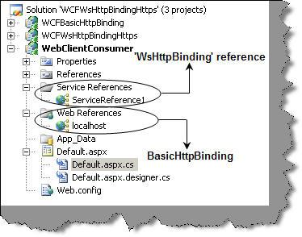
We will add two buttons on the default aspx page. One button will call the http service and the other will call the wshttp service. Below is how the function ‘GetData’ is called in both the button clicks.
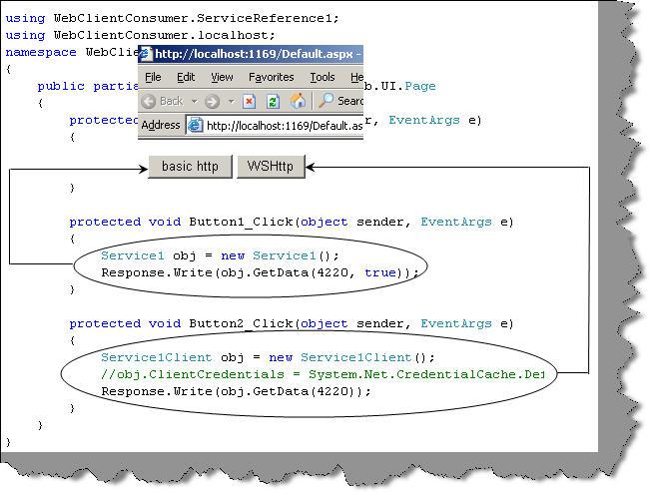
Step 5 :- So now we are ready with the complete project it is time to sniff and see how data is transported between client and the service in both the scenarios. So let’s download a simple http data recorder from http://www.ieinspector.com/httpanalyzer/download.html . We will then click both the buttons one by one and record the data transfer using httpanalyzer. You can see the posted data is in simple plain XML format for basic http protocol and it’s in an encrypted format for wshttp protocol.

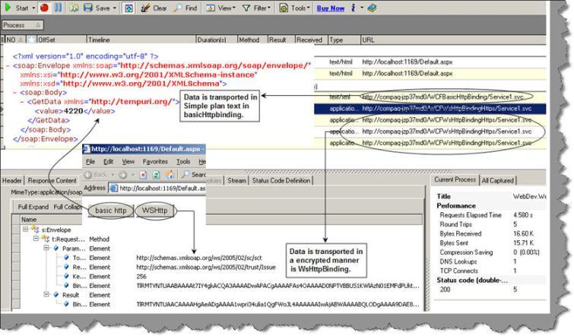

57) How can we enable windows authentication on WCF using ‘BasicHttpBinding’? Part-2
Step 6:- We need to host our service in the IIS. So make the directory as an IIS application so that your service can be hosted. Now if you try to browse the service i.e. the SVC file you will see that it pops up the authentication authorization security dialog box. So this service cannot be executed with windows authentication.

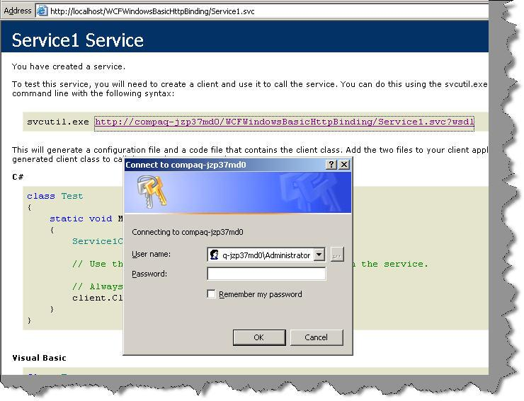
Step 7:- So let’s consume this WCF services. So add an ASP.NET webapplication and do a add webreference. You will be popped up with a dialog box as shown below. Click on add reference so that a proxy is generated for the WCF service.

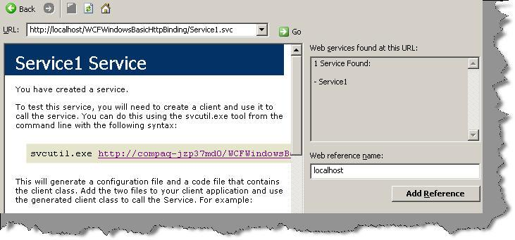
Step 8:- Type in the following code snippet in your page load. So add the namespace reference and call the method ‘GetData’. The most important step to note is the credential supplied. ‘DefaultCredentials’ passes the current windows identity to the WCF service.

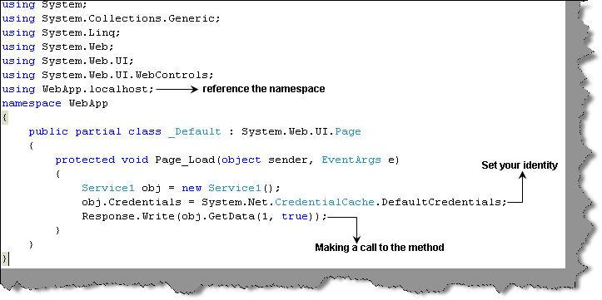

If you execute the service you should get the following display as shown below.
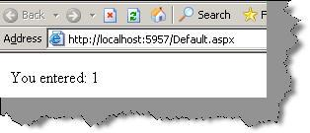
You can try commenting the below code in your client in other words we are not passing any credentials.
obj.Credentials = System.Net.CredentialCache.DefaultCredentials;
Now if you execute you should get the below error stating that this is a unauthorized call.
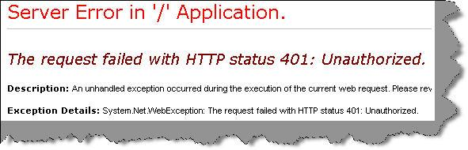
Source Code
Whatever code we have discussed in the above FAQ . You can download the Source Code from here
58) How can we enable windows authentication on WCF using ‘BasicHttpBinding’? Part-1
Step 1:- Create a project of WCF service application as shown in the below figure.

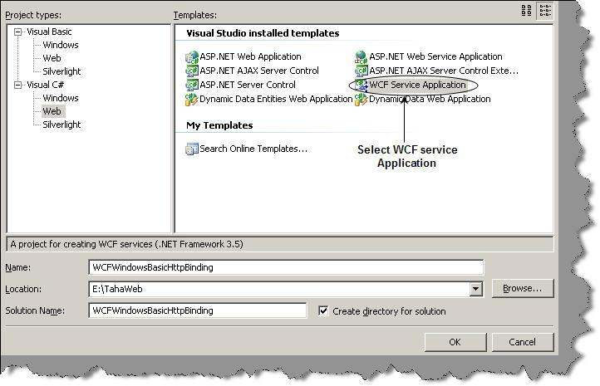
Circle WCF service application ?Select this
By default the WCF project creates a class file which has ‘GetData’ function. This function takes in a number values and displays a explanatory sentence like ‘You entered 1 value’ , in case you have entered ‘1’.
public class Service1 : IService1
{
public string GetData(int value)
{
return string.Format("You entered: {0}", value);
}
}
Step 2:- When we create a WCF service application it also has a web.config file associated with it. So open the web.config file and ensure that authentication mode is windows.
<authentication mode="Windows" />

Step 3:- The third step is to define the bindings and the transport type. To define the bindings we need to enter ‘basicHttpBinding’ element inside the ‘bindings’ XML tag. We also need to define the ‘clientCredentialType’ as windows.
<system.serviceModel>
<bindings>
<basicHttpBinding>
<binding name="BasicHttpEndpointBinding">
<security mode="TransportCredentialOnly">
<transport clientCredentialType="Windows" />
</security>
</binding>
</basicHttpBinding>
</bindings>
<services>
.........
.........
</system.serviceModel>
Step 4:- Now the bindings defined needs to be associated with service interface i.e. ‘service1’. So we need to modify the services elements as shown below. You can note that we have defined a end point which has the binding association.
<system.serviceModel>
........
........
........
<services>
<service behaviorConfiguration="WCFWindowsBasicHttpBinding.Service1Behavior" name="WCFWindowsBasicHttpBinding.Service1">
<endpoint address="" binding="basicHttpBinding"
bindingConfiguration="BasicHttpEndpointBinding"
name="BasicHttpEndpoint" contract="WCFWindowsBasicHttpBinding.IService1">
<identity>
<dns value="localhost" />
</identity>
</endpoint>
</service>
</services>
.........
.........
.........
.........
</system.serviceModel>
So over all your <system.serviceModel> XML part as whole with bindings and services is a shown below.
<system.serviceModel>
<bindings>
<basicHttpBinding>
<binding name="BasicHttpEndpointBinding">
<security mode="TransportCredentialOnly">
<transport clientCredentialType="Windows" />
</security>
</binding>
</basicHttpBinding>
</bindings>
<services>
<service behaviorConfiguration="WCFWindowsBasicHttpBinding.Service1Behavior" name="WCFWindowsBasicHttpBinding.Service1">
<endpoint address="" binding="basicHttpBinding"
bindingConfiguration="BasicHttpEndpointBinding"
name="BasicHttpEndpoint" contract="WCFWindowsBasicHttpBinding.IService1">
<identity>
<dns value="localhost" />
</identity>
</endpoint>
</service>
</services>
<behaviors>
<serviceBehaviors>
<behavior name="WCFWindowsBasicHttpBinding.Service1Behavior">
<!-- To avoid disclosing metadata information, set the value below to false and remove the metadata endpoint above before deployment -->
<serviceMetadata httpGetEnabled="true"/>
<!-- To receive exception details in faults for debugging purposes, set the value below to true. Set to false before deployment to avoid disclosing exception information -->
<serviceDebug includeExceptionDetailInFaults="false"/>
</behavior>
</serviceBehaviors>
</behaviors>
</system.serviceModel>
Step 5 :- Go to IIS properties and click on security tab and ensure that anonymous access is disabled and only windows authentication is enabled.
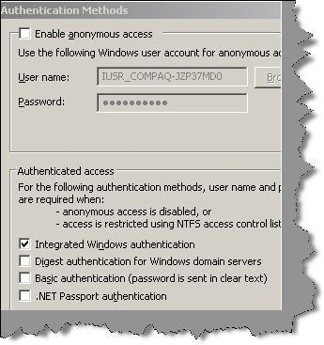
Countinue Part 2
59) When should we use WsHttp as compared to BasicHttp ?
If you are looking for back ward compatibility and to support lot of clients then basic http binding is the way to go or else WsHttp is the great way to start if you are seeing your clients made in .NET 3.0 and above.
60) So what are the scenarios, advantages and disadvantages of transport VS message security?
 | Transport | Message
Scenarios when we should be using one of them | When there are no intermediate systems in between this is the best methodology.  If it’s an intranet type of solution this is most recommended methodology. | When there are intermediate systems like one more WCF service through which message is routed then message security is the way to go.
Advantages | Does not need any extra coding as protocol inherent security is used.  Performance is better as we can use hardware accelerators to enhance performance.  There is lot of interoperability support and communicating clients do not need to understand WS security as it’s built in the protocol itself. | Provides end to end security as it’s not dependent on protocol. Any intermediate hop in network does not affect the application.  Supports wide set of security options as it is not dependent on protocol. We can also implement custom security.
Disadvantages | As it’s a protocol implemented security so it works only point to point.  As security is dependent on protocol it has limited security support and is bounded to the protocol security limitations. | Needs application refactoring to implement security.  As every message is encrypted and signed there are performance issues.  Does not support interoperability with old ASMX webservices/
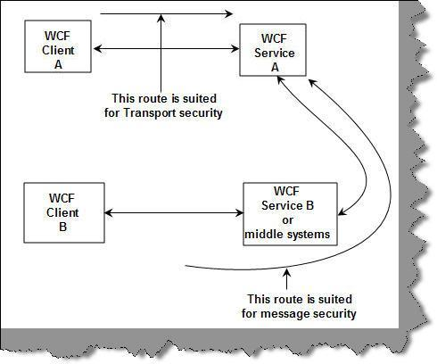
Figure: - Route paths
For which bindings are transport, message and mixed mode supported?
Note :- The below table is taken from book Pro WCF: Practical Microsoft SOA Implementation -- Chris peiris and Denis mulder – Apress 2007
Below is a table which shows for which binding which mode is supported. We did not discuss the mixed mode. It’s nothing but combination of transport and mixed mode. For instance data encrypted and passed over WsHttp using HTTPS is a mixed mode of security. Encryption is nothing but message security and HTTPS is a transport mode. In a combination they form mixed mode.
Binding | Transport Mode? | Message Mode? | Mixed Mode?
BasicHttpBinding | Yes | Yes | Yes
WsHttpBinding | Yes | Yes | Yes
WsDualHttpBinding | No | Yes | No
NetTcpBinding | Yes | Yes | Yes
NetNamedPipeBinding | Yes | No | No
NetMsmqBinding | Yes | Yes | No
MsmqIntegrationBinding | Yes | No | No
61) What is transport level and message level security?
When we talk about WCF security there are two aspects, the first is the data and the second is the medium on which the data travels i.e. the protocol. WCF has the ability to apply security at the transport level (i.e. protocol level) and also at message level (i.e. data).

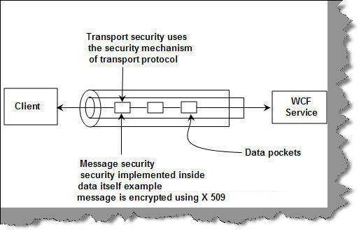
Figure: - Transport and Message level security
Transport level security happens at the channel level. Transport level security is the easiest to implement as it happens at the communication level. WCF uses transport protocols like TCP, HTTP, MSMQ etc and every of these protocols have their own security mechanisms. One of the common implementation of transport level security is HTTPS. HTTPS is implemented over HTTP protocols with SSL providing the security mechanism. No coding change is required it’s more of using the existing security mechanism provided by the protocol.
Message level security is implemented with message data itself. Due to this it is independent of the protocol. Some of the common ways of implementing message level security is by encrypting data using some standard encryption algorithm.
62) What are the core security features that WCF addresses?
There are four core security features that WCF addresses:-
Confidentiality: This feature ensures that the information does not go in wrong hands when it travels from the sender to the receiver.
Integrity: This feature ensures that the receiver of the message gets the same information that the sender sends without any data tampering.
Authentication: This feature verifies who the sender is and who the receiver is.
Authorization: This feature verifies whether the user is authorized to perform the action they are requesting from the application.

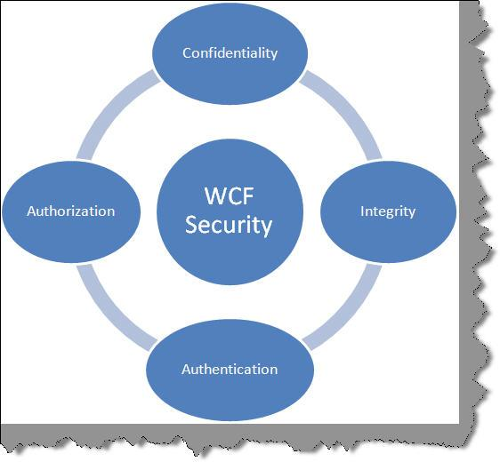

63) What the different transaction options ?
In the previous code we have use ‘TransactionFlowOption’. We can specify transaction in 3 ways in WCF:-
TransactionFlowOption.NotAllowed
This is a default option. Using this option no transaction will be propagated across the binding. If any client attempts to call the WCF service in a transaction it will be ignored for this option.
TransactionFlowOption.Allowed
This option specifies that client can call this WCF service in a transaction. It’s not compulsory that the service needs to be called in a transaction. You can call without the transaction also.
TransactionFlowOption.Mandatory
This option specifies that client must call the WCF service in a transaction mode. If the WCF service is called without transaction, ‘FaultException’ will be raised.
64) Can we see simple WCF example of transactions using SQL Server database?
To enable WCF transaction is a 6 step procedure. So let’s create two WCF services and let’s try to call them in one transaction.
Step 1 :- Create two WCF service
The first step is to create two WCF service projects which will participate in one transaction. In both of these WCF services we will do database transactions and we will try to understand how a WCF transaction unifies them. We have also created a web application with name ‘WCFTransactions’ which will consume both the service in one transaction scope.
Step 2:- Attribute interface methods with TransactionFlow
In both the WCF service we will create a method called as ‘UpdateData’ which will do insert in to the database. So the first thing is to create the interface class with ‘ServiceContract’ attribute and the method ‘UpdateData’ with ‘OperationContract’ attribute. In order to enable transaction in ‘UpdateData’ method we need to attribute it with ‘TransactionFlow’ and we have specified that transactions are allowed for this method using ‘TransactionFlowOption.Allowed’ enum.
[ServiceContract]
public interface IService1
{
[OperationContract]
[TransactionFlow(TransactionFlowOption.Allowed)]
void UpdateData();
}
Step 3:- Attribute the implementation with ‘TransactionScopeRequired’
The 3rd step is to attribute the implementation of the WCF services with ‘TransactionScopeRequired’ as true. Below is the code snippet which has a simple database inserting function i.e. ‘UpdateData’ which is attributed by ‘TransactionScopeRequired’ attribute.
[OperationBehavior(TransactionScopeRequired = true)]
public void UpdateData()
{
SqlConnection objConnection = new SqlConnection(strConnection);
objConnection.Open();
SqlCommand objCommand = new SqlCommand("insert into Customer(CustomerName,CustomerCode) values('sss','sss')",objConnection);
objCommand.ExecuteNonQuery();
objConnection.Close();
}
Step 4:- Enable transaction flow using WCF service config file
We also need to enable transactions for ‘wsHttpBinding’ by setting the ‘transactionFlow’ attribute to true.
<bindings>
<wsHttpBinding>
<binding name="TransactionalBind" transactionFlow="true"/>
</wsHttpBinding>
</bindings>
The transaction enabled binding we need to attach with the end point through which our WCF service is exposed.
<endpoint address="" binding="wsHttpBinding" bindingConfiguration="TransactionalBind" contract="WcfService1.IService1">
Step 5:- Call the 2 services in one transaction
Now that we are done with our server side transaction enablement, it’s time to call the above 2 services in 1 transaction. We need to use the ‘TransactionScope’ object to group the above 2 WCF services in one transaction. To commit all the WCF transactions we call the ‘Complete’ method of the ‘Transactionscope’ object. To rollback we need to call the ‘Dispose’ method.
using (TransactionScope ts = new TransactionScope(TransactionScopeOption.RequiresNew))
{
try
{
// Call your webservice transactions here
ts.Complete();
}
catch (Exception ex)
{
ts.Dispose();
}
}
Below is the complete code snippet in which we have grouped both the WCF transactions in one scope as shown below.
using (TransactionScope ts = new TransactionScope(TransactionScopeOption.RequiresNew))
{
try
{
ServiceReference1.Service1Client obj = new ServiceReference1.Service1Client();
obj.UpdateData();
ServiceReference2.Service1Client obj1 = new ServiceReference2.Service1Client();
obj1.UpdateData();
ts.Complete();
}
catch (Exception ex)
{
ts.Dispose();
}
}
Step 6:- Test does your transaction work
It’s time to test if the transactions really work. We are calling two services both of these services are doing an insert. After the first WCF service call we are forcing an exception. In other words the data insert of the first WCF service should revert back. If you check the database records you will see no records are inserted by the WCF service.
65) Can we implement transactions in one-way WCF service calls?
As we have already seen in the previous questions that WCF transactions are 2-phase commits. In other words for every commit you need to get a confirmation response, saying is the commit successful. In one-way WCF services we do not get any response back , so WCF transactions are not possible with 1 way WCF service calls.
66) Can you explain in depth how prepare and commit phases work?
Let’s consider 3 computers as shown in the below figure. The client consuming the WCF service resides in computer ‘A’ while computer ‘B’ and ‘C’ have the WCF services. The transaction is initiated from the computer ‘A’. So as we said previously there are 2 phase one is the prepare phase and the other commit phase. In prepare phase computer ‘A’ sends messages to all the WCF services saying, are they ready to commit?. Once all WCF services respond saying that they are ready for commit it starts the second phase i.e. In the second phase the WCF client issues a commit command. All the WCF services start execution and once they are done they revert back saying they have committed. When all the WCF services revert saying they have committed the transaction is marked as successful.
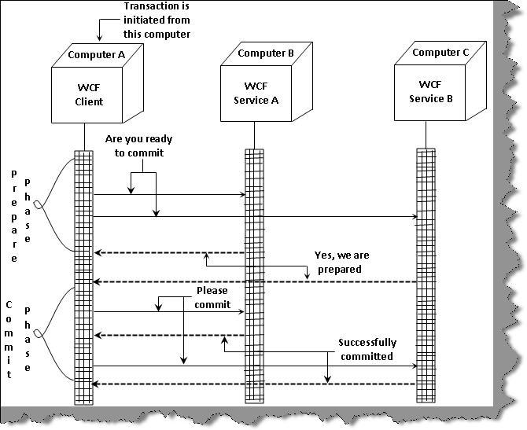

67) Where does the transaction manager reside?
Transaction manager resides at the client computer who initiates the transaction.
68) What are the two different kinds of phases in WCF transactions?
WCF transactions follow 2 phase commit. So there are 2 phases one is the prepare phase and the other is the commit phase. All co-ordination of transactions is done by the transaction manager.
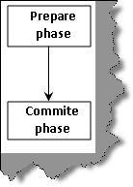
In prepare phase the transaction manager checks whether all entities are prepared to commit. In commit phase the actual commit starts. You can think about prepare phase as a check saying that all entities are ready to commit and in the commit phase we do the actual work.
69) Which protocol is used to handle transactions in WCF?
WCF follows WS-* specifications. So it uses WS-Atomic protocol to managed transaction across WCF services. So you can have different WCF services hosted on different computers and they all can run under one transaction unit. The best part of WS-Atomic protocol is that in one transaction you can have heterogeneous WCF services developed in different platform. In other words you can have JAVA and .NET web services running under one transaction. WS-* specifications are globally approved standards to create services.

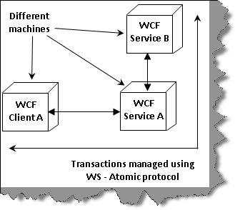
70) What are Dead letter queues?
The main use of queue is that you do not need the client and the server running at one time. Therefore, it is possible that a message will lie in queue for long time until the server or client picks it up. But there are scenarios where a message is of no use after a certain time. Therefore, these kinds of messages if not delivered within that time span it should not be sent to the user.
Below is the config snippet, which defines for how much time the message should be in queue.
<bindings>
<netMsmqBinding>
<binding name="MyBindings"
deadLetterQueue="Custom"
customDeadLetterQueue="net.msmq://localhost/private/ServiceModelSamples"
timeToLive="00:00:02"/>
</netMsmqBinding>
71) What are Volatile queues?
There are scenarios in the project when you want the message to deliver in proper time. The timely delivery of message is more important than losing message. In these scenarios, Volatile queues are used.
Below is the code snippet, which shows how to configure Volatile queues. You can see the binding Configuration property set to Volatile Binding. This code will assure that message will deliver on time but there is a possibility that you can lose data.
<appSettings>
<!-- use appSetting to configure MSMQ queue name -->
<add key="queueName" value=".\private$\ServiceModelSamplesVolatile" />
</appSettings>
<system.serviceModel>
<services>
<service name="Samples.StockTickerServ"
behaviorConfiguration="CalculatorServiceBehavior">
...
<!-- Define NetMsmqEndpoint -->
<endpoint address="net.msmq://localhost/private/ServiceModelSamplesVolatile"
binding="netMsmqBinding"
bindingConfiguration="volatileBinding"
contract="Samples.InterfaceStockTicker" />
...
</service>
</services>
<bindings>
<netMsmqBinding>
<binding name="volatileBinding"
durable="false"
exactlyOnce="false"/>
</netMsmqBinding>
</bindings>
...
</system.serviceModel>
72) Can we do transactions using MSMQ?
While doing MSMQ there can be scenarios in the project, where we would like all the messages are uploaded to either MSMQ or all messages read from MSMQ. After any message is read from MSMQ, it is deleted from the queue. Therefore, some times this can be critical if there are exceptions in reading or uploading messages. As said before WCF transaction can be applied to database as well as other operations like MSMQ. So let us try to understand the same by doing a small sample.
Below is a numbered code snippet of MSMQ transactions.
1 - Send message is the exposed method in the service. We have marked this method as TransactionScopeRequired=true
2 - On the client side we have use the transaction scope to say that we are starting a transaction to MSMQ server. You can see we have used the send Message to send the messages to MSMQ.
3- We can then use Complete or Dispose method to complete or rollback the transactions.
The below MSMQ transaction code ensures that either all messages are send to the server or none are sent. Thus satisfying consistency property of transactions.

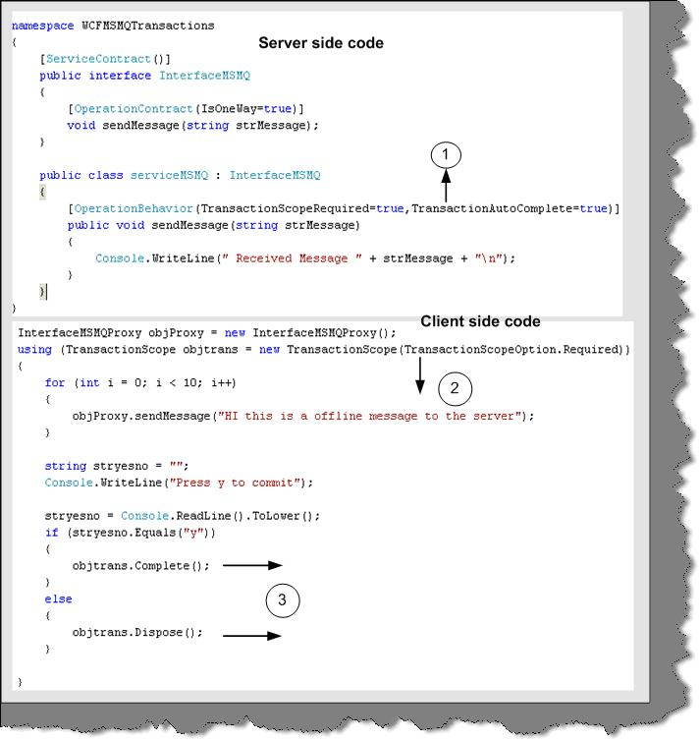
Figure 27:- Transaction snippet code

73) What different transaction isolation levels provided in WCF?
Transactions assure that a group of related activity occurs as a single atomic unit. In simple words, every activity in the unit must either all succeed or all should fail. WCF provides a central transaction system that can be used to handle transaction operations. One of the things WCF provides is a single unified transaction system for both database and non-database activity. For instance, BeginTrans and CommitTrans are database related syntaxes but we can not use the same for other activities like if we want to upload all message in a single transaction to a MSMQ server. One thing to note is that WCF transaction abides to WS specifications. That means any other language like JAVA can take advantage of this transaction…. I think that is the best part of WCF embracing other languages. 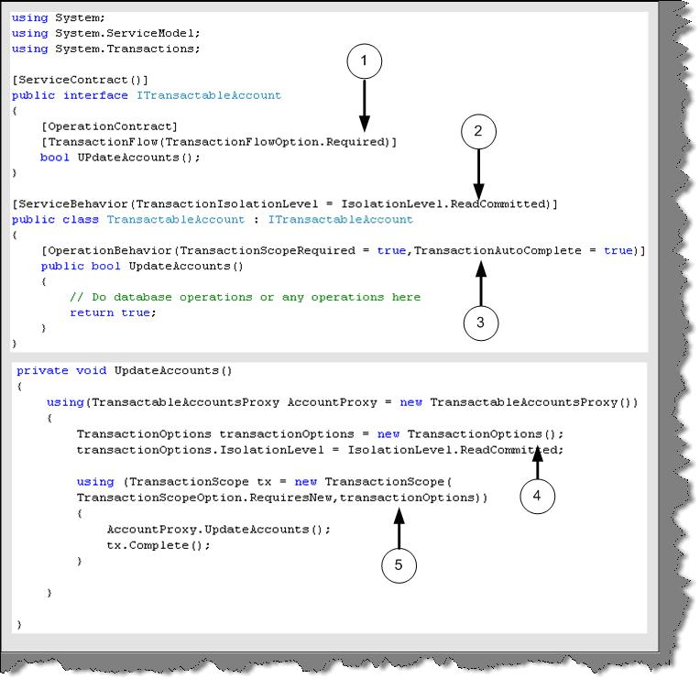
Figure 26:- Transactions in WCF
In order to support transaction the service should first support transactions. Above is a simple code snippet of the server service and client and explanation for the same:-
The top code snippet is of the server service and the below code snippet is of the client.
1 - At interface level the operation contract is attributed with [Transaction Flow] attribute. There are three values for it Allowed (which mean operation mar or may not be used in transaction), Not Allowed (Where it is never used in transaction) and required (Where the service can only be used in transactions). Below code snippet currently says that this service can only be used with transactions.
2 - In this section the [Service Behavior] attribute specifies the transaction isolation level property. Transaction isolation specifies the degree of isolation most compatible with other applications. So let us review what are the different levels you can provide in transaction isolation.
The data affected by a transaction is called volatile.
Chaos: - pending changes from more highly isolated transactions cannot be overridden.
Read Committed: - Volatile data can be modified but it cannot be read during the transaction.
Read Uncommitted: - Volatile data can be read as well as modified during the transaction.
Repeatable Read: - Volatile data can be read but not modified during the transaction and new data can be added.
Serializable: - Volatile data can be only read. However, no modifications and adding of new data is allowed.
Snapshot: - Volatile data can be read. However, before modifying the data it verifies if any other transaction had changed data. If yes then it raises error.
By default, the System. Transactions infrastructure creates Serializable transactions.
3 - This defines the transaction behavior with in the service. [Operation Behavior] has a property called as transaction scope. Transaction Scope setting indicates that operation must be called within a transaction scope. You can also see TransactionAutoComplete is set to true which indicates that transaction will complete by default if there are no errors. If you do not provide the TransactionAutoComplete to true then you will need to call OperationContext.Current.SetTransactionComplete() to make the transaction complete.
Now let us make a walkthrough of the client side code for the service.
4 and 5 - You can see from the client we need to define Isolation level and the scope while making the call to our Update Accounts method.
74) How can we use MSMQ bindings in WCF?
First let us understand why MSMQ came in to picture and then rest will follow. Let us take a scenario where your client needs to upload data to a central server. If everything will works fine and the server is available 24 hours to client then there are no issues. In case the server is not available, the clients will fail and the data will not be delivered. There is where MSMQ comes in to picture. It eliminates the need of persistent connection to a server. Therefore, what you do is deploy a MSMQ server and let the clients post message to this MSMQ server. When your actual server runs, it just picks up the message from the queue. In short, neither the client nor the server needs to be up and running on the same time. In WCF we have a client and service model and in real world it is very much practical possible that both the entities will not be available at one time.
In order to use MSMQ you need to install the Message queuing by click on Install windows component and selecting MSMQ queuing. Once that done we are all set to make our sample of MSMQ using WCF

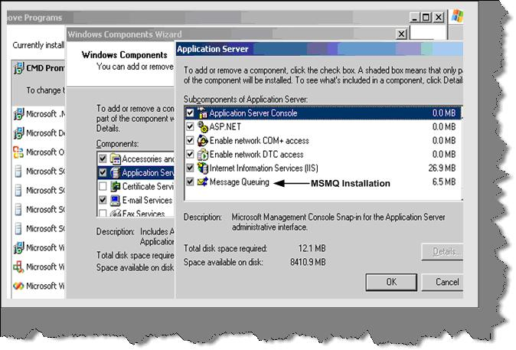
Figure 22:- MSMQ Installation
This sample will be simple. We send some messages from the client and keep the server down. As the server is down it will make postings to the MSMQ server. Then we will run the server service and service should pick up the message and display the same.

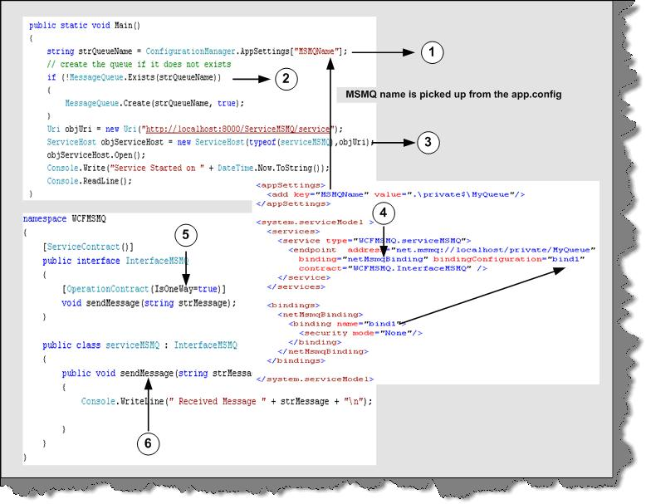
Figure 23:- MSMQ Server side code walkthrough
Above snippet is the server side code. So let us understand the whole snippet:-
1 – First thing is the queue name where the messages will go if the server is not running. The server name we can get from the config file. You can see in the above snippet we have defined the Mismanage in App.config file.
2 – We first check does this queue exist if it exists then go-ahead. If not then go to create a queue. Please note you need import using System. Messaging namespace. Then we can use the Message Queue to create a queue if the queue does not exist.
3 – First thing which should surprise you is why we are creating a URI with HTTP protocol as we are going to use MSMQ. Ok! This is bit tricky but fun. As we know in order to connect to this service, we need to generate a client proxy using SVCUTIL. Therefore, this URI will help us do that. It is not actually used by the client to connect.
4 – We need our end and the MSMQ bindings.
5 and 6 – Again as usual we need is an interface and implementation for the same. In implementation we have created a method called send Message.
Once the above steps are executed, run the server and generate the client proxy using SVCUTIL utility.
Now comes the final step making a client. One change you need to make is change the address to the MSMQ server in the app.config. In this, we have just looped ten times and fired an offline message. Please note to keep your server down.

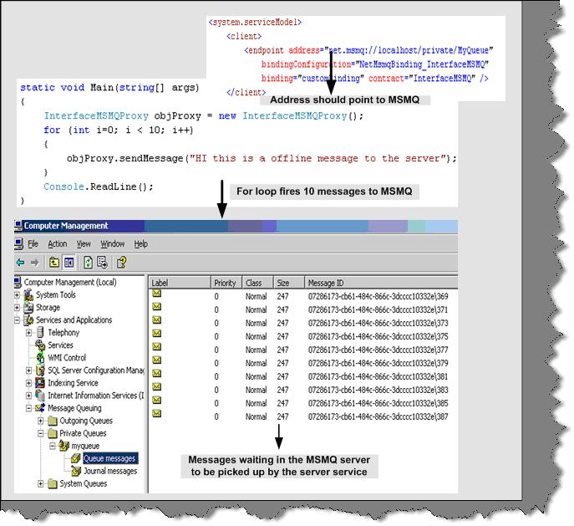
Figure 24:- MSMQ Client side code

Now go to computer management and you can see your queue messages waiting to be picked by the server. Run the server and below should be the output. If you come back again you will see that there are no messages in the queue.

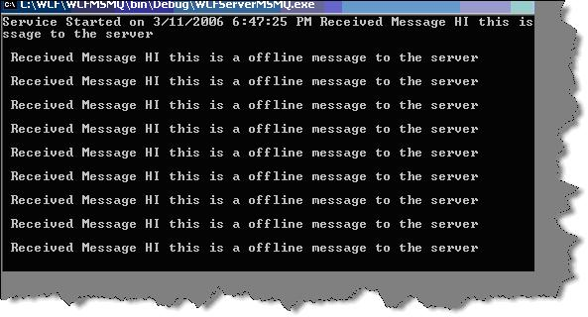
Figure 25:- MSMQ Server side display
One of the important concepts is to understand when to use MSMQ protocol. When we expect that client and server will not be available, at one time this is the best option to opt for.
75) How can we host a service on two different protocols on a single server?
Let us first understand what this question actually means. Let us say we have made a service and we want to host this service using HTTP as well as TCP. You must be wondering why to ever host services on two different types of protocol. When we host a service, multiple types of client consume it and it’s very much possible that they have there own protocol of communication. A good service has the capability to downgrade or upgrade its protocol according the client who is consuming him.
Let us do a small sample in which we will host the ServiceGetCost on TCP and HTTP protocol.
Note: - You can the below sample in “WCFMultipleProtocolGetHost” folder in the CD provided.

76) Below is the code snippet pasted from the same sample?
As usual, we have numbered them and here is the explanation of the same:-
1 and 2 - As we are hosting the service on two protocols we need to create two objects if the URI. You can also give the URI through config file. Pass these two objects of the URI in the constructor parameter when creating the service host object.
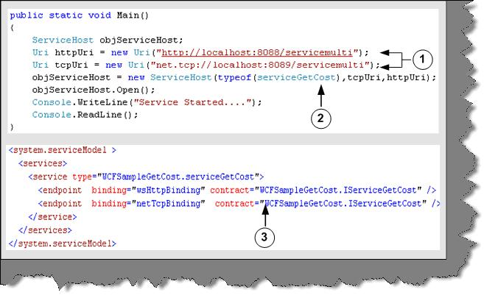
Figure 20:- Server side code for Multi Protocol hosting
3 – In the config file we need to define two bindings and end as we are hosting the service in multiple protocols.
Once we are done the server side coding its time to see make a client by which we can switch between the protocols and see the results. Below is the code snippet of the client side for multi-protocol hosting.

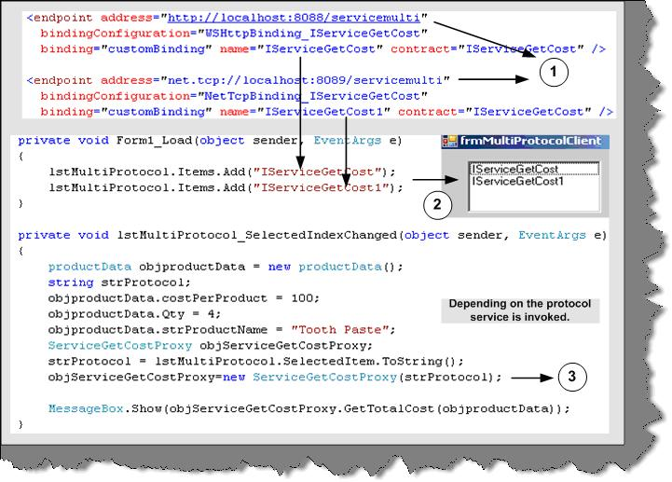
Figure 21:- Multi Protocol Client code
Let us understand the code:-
1 - In the generated config file we have added two ends. When we generate the config file, it generates only for one protocol. The other end has to be manually added.
2 - To test the same we have a list box, which has the name value given in the end point.
3 - In the list box select event we have then loaded the selected protocol. The selected protocol string needs to be given in the proxy class and finally call the proxy class GetTotalCost.
77) Can you explain duplex contracts in WCF?
In duplex contracts when client initiates an operation the server service provides a reference call back Uri back to the client. So the client initiates a call using the proxy class and when server finishes its work it notifies the client using the callback channel. This is called as duplex messaging in WCF. If you remember in the previous question, we had no way to know when the server finished its task.

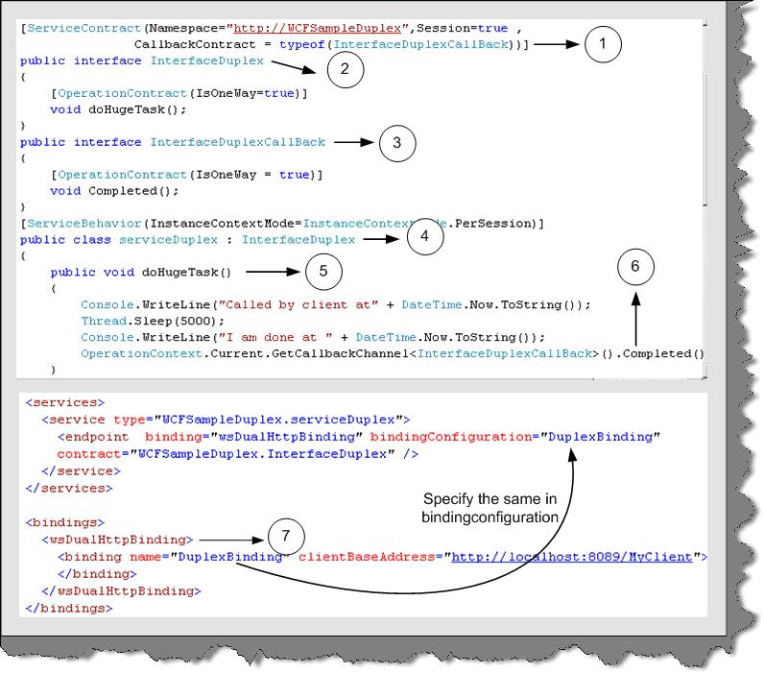

Figure 18:- Duplex Service code
Let us try to understand the duplex concept by doing a small sample. The code snippet is as shown in the above figure. We will extend the previous sample, which was shown in the first question only that now we will provide the notification to the client once the doHugeTask is completed.
The first step is to change the service class. Above is the code snippet of the service class. Again, we have numbered them so that we can understand how to implement it practically line by line. So below is the explanation number by number:-
1 - In the service contract attribute we need to specify the callback contract attribute. This Callback Contract attribute will have the interface, which will define the callback.
2 - This is the interface which client will call. In order that it should be asynchronous, we have defined the one-way attribute on the doHugeTask method.
3 -This is the most important interface. As it forms the bridge of communication between server and client. The server will call the client using Completed method. Client needs to provide implementation for the completed method at the client side and server will call that method once it completes the doHugeTask method.
4 and 5 - In this we implement the Interface Duplex interface and provide implementation for doHugeTask () method.
6 - This is an important step. The OperationContext.Current.GetCallBackChannel will be used to make callback to the client.
7 - We will expose the service using HTTP protocol. In this sample, because we want to do duplex communication we need to use wsDualHttpBinding rather than just using simple Http Binding. This new binding configuration is then assigned to the end on which the service is hosted.
This completes the server side explanation for duplex.

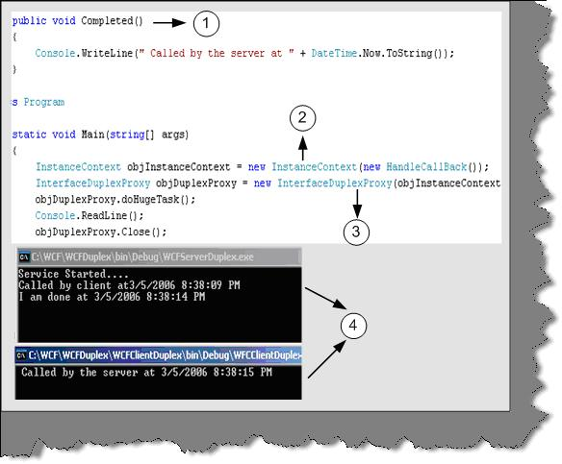
Figure: - 19 Duplex Client side code
Above is the code snippet for client side. So let us explain the above code with numbers.
1- We implement the completed method. This is the callback method, which the server will call when doHugeTask is completed.
2- In this step we create object of the Instance Context class. Instance Context represents context information of a service. The main use of Instance Context is to handle incoming messages. In short, proxy is used to send messages to server and Instance Context is used to accept incoming messages.
3 -In this step we pass the Instance Context object to the constructor of the proxy. This is needed, as the server will use the same channel to communicate to the client.
4 - In this section two windows are shown. The top windows is the servers output and the below windows is of the client. You can see in the below window that server as made a callback to the client.
Note: - You can get source code for the same in WCFDuplex folder. Feel Free to experiment with it. Try making one simple project of client to client chat using WCF duplex fundamentals I am sure your doubts will be cleared in and out.
78) What is one-way operation?
IsOneWay equal to true ensures that the client does not have to wait for the response. So methods marked by IsOneWay to true should always return void. In this, the caller does not get anything in return so it is called as one-way communication.
In order to understand one-way implementation in WCF lets make a code walkthrough of a sample.
Note: - You can find code for the same in “WCFIsOneWay” folder in CD.
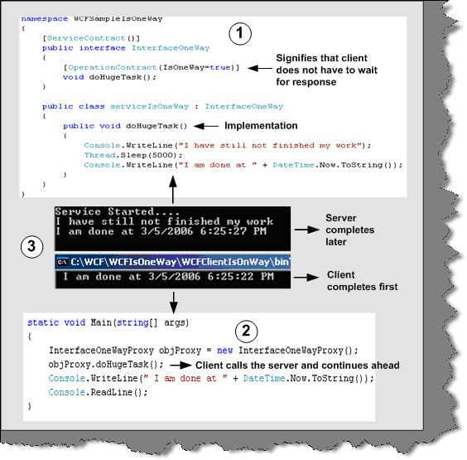
Figure 17: - One-Way in action
Above is the code snippet, which describes practically how one way works in WCF. The above given code snippet is numbered. Below is the explanation according to the numbers marked in figure:-
1 - This is the code snippet of the server service. We have created a method called as doHugeTask. DoHugeTask makes the method sleep for 5000 MS and then displays the time when the task is completed.
2 - This code snippet is for client. It creates a proxy object of serviceIsOneWay and calls the doHugeTask method. After calling the doHugeTask, the client execution continues ahead. So as a proof, we display the time when the method calling was completed.
3 - This screen shot shows the output given by both server and client. The top window displays the server output and the below windows displays the client output.
Note: - You can find the code for the same in WCFIsOneWay folder. For generating the proxies you have to follow the same steps which are shown in the previous steps.
So run the server program first i.e. ServiceIsOneWay and run the client later. You will see the client runs the doHugeTask and moves ahead. Therefore, the client completion time is less than the server is. One more thing to understand is that one way does not give any notification back of completion. Therefore, it is like fire and forgets.
79) what are the advantages of hosting WCF Services in IIS as compared to self-hosting?
There are two main advantages of using IIS over self-hosting:-
Automatic activation
IIS provides automatic activation that means the service is not necessary to be running in advance. When any message is received by the service it then launches and fulfills the request. But in case of self hosting the service should always be running.
Process recycling
If IIS finds that a service is not healthy that means if it has memory leaks etc, IIS recycles the process. Ok let us try to understand what is recycling in IIS process. For every browser instance, a worker process is spawned and the request is serviced. When the browser disconnects the worker, process stops and you loose all information. IIS also restarts the worker process. By default, the worker process is recycled at around 120 minutes. So why does IIS recycle. By restarting the worker process it ensures any bad code or memory leak do not cause issue to the whole system.
In case of self-hosting both the above features, you will need to code yourself. Lot of work right!!. That is why IIS is the best option for hosting services until you are really doing something custom.
Below figure shows where the recycle option is located in IIS. You need to click on the DefaultAppool and then Properties.

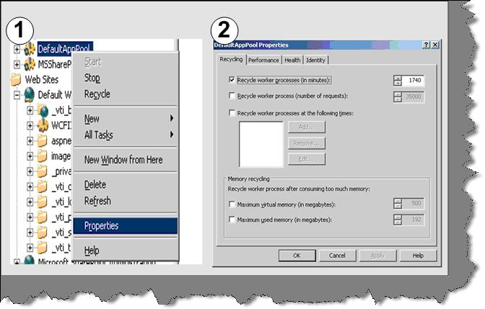

Figure 16:- IIS recycle option
80) What the different transaction options ?
In the previous code we have use ‘TransactionFlowOption’. We can specify transaction in 3 ways in WCF:-
TransactionFlowOption.NotAllowed
This is a default option. Using this option no transaction will be propagated across the binding. If any client attempts to call the WCF service in a transaction it will be ignored for this option.
TransactionFlowOption.Allowed
This option specifies that client can call this WCF service in a transaction. It’s not compulsory that the service needs to be called in a transaction. You can call without the transaction also.
TransactionFlowOption.Mandatory
This option specifies that client must call the WCF service in a transaction mode. If the WCF service is called without transaction, ‘FaultException’ will be raised.
81) What are Dead letter queues?
The main use of queue is that you do not need the client and the server running at one time. Therefore, it is possible that a message will lie in queue for long time until the server or client picks it up. But there are scenarios where a message is of no use after a certain time. Therefore, these kinds of messages if not delivered within that time span it should not be sent to the user.
Below is the config snippet, which defines for how much time the message should be in queue.
<bindings>
<netMsmqBinding>
<binding name="MyBindings"
deadLetterQueue="Custom"
customDeadLetterQueue="net.msmq://localhost/private/ServiceModelSamples"
timeToLive="00:00:02"/>
</netMsmqBinding>
82) What are Volatile queues?
Answers:- There are scenarios in the project when you want the message to deliver in proper time. The timely delivery of message is more important than losing message. In these scenarios, Volatile queues are used.
Below is the code snippet, which shows how to configure Volatile queues. You can see the binding Configuration property set to Volatile Binding. This code will assure that message will deliver on time but there is a possibility that you can lose data.
<appSettings>
<!-- use appSetting to configure MSMQ queue name -->
<add key="queueName" value=".\private$\ServiceModelSamplesVolatile" />
</appSettings>
<system.serviceModel>
<services>
<service name="Samples.StockTickerServ"
behaviorConfiguration="CalculatorServiceBehavior">...
<!-- Define NetMsmqEndpoint -->
<endpoint address="net.msmq://localhost/private/ServiceModelSamplesVolatile"
binding="netMsmqBinding"
bindingConfiguration="volatileBinding"
contract="Samples.InterfaceStockTicker" />
...
</service>
</services>
<bindings>
<netMsmqBinding>
<binding name="volatileBinding"
durable="false"
exactlyOnce="false"/>
</netMsmqBinding>
</bindings>
...
</system.serviceModel>
83) What are different bindings supported by WCF?
Answer: -
WCF includes predefined bindings. They cover most of bindings widely needed in day-to-day application. However, just incase you find that you need to define something custom WCF does not stop you. So let us try to understand what each binding provides.
BasicHttpBinding: - This binding is used when we need to use SOAP over HTTP. This binding can also be configured to be used as HTTPS. It can be also configured to send data in plain text or in optimized form like MTOM.
WsHttpBinding: - It is same like BasicHttpBinding. In short, it uses SOAP over HTTP. But with it also supports reliable message transfer, security and transaction. WS-Reliable Messaging, security with WS-Security, and transactions with WS-Atomic Transaction supports reliable message.
NetTcpBinding: - This binding sends binary-encoded SOAP, including support for reliable message transfer, security, and transactions, directly over TCP. The biggest disadvantage of NetTcpBinding is that both server and client should be also made in .NET language.
NetNamedPipesBinding:-Ths binding Sends binary-encoded SOAP over named pipes. This binding is only usable for WCF-to-WCF communication between processes on the same Windows-based machine.
Note: - An interprocess control (IPC) protocol is used for exchanging information between two applications, possibly running on different computers in a network. The difference between Named pipes and TCP is that named pipes have good performance in terms of communication with in processes. But when it comes to communicate across network TCP holds the best choice. So if you are using WCF to communicate with process it’s the best choice to use in terms for performance. Named pipes do not perform when the traffic is heavy as compared to TCPIP.
NetMsmqBinding: - This binding sends binary-encoded SOAP over MSMQ. This binding can only be used for WCF-to-WCF communication.
84) What are the major differences between services and Web services? OR What is the difference WCF and Web services?
Answer: -
Web services can only be invoked by HTTP. While Service or a WCF component can be invoked by any protocol and any transport type. Second web services are not flexible. However, Services are flexible. If you make a new version of the service then you need to just expose a new end. Therefore, services are agile and which is a very practical approach looking at the current business trends.

85) What are the various ways of hosting a WCF service?
Answer: -
There are three major ways to host a WCF service:-
• Self-hosting the service in his own application domain. This we have already covered in the first section. The service comes in to existence when you create the object of Service Host class and the service closes when you call the Close of the Service Host class.
• Host in application domain or process provided by IIS Server.
• Host in Application domain and process provided by WAS (Windows Activation Service) Server.
86) What are the main components of WCF?
Answer: -
We need to define three main components in WCF:-
• Service class.
• Hosting environment
• End point
87) Which specifications does WCF follow?
Answer: -
WCF supports specifications defined by WS-* specifications. WS-* specifications are defined together by Microsoft, IBM, SUN and many other big companies so that they can expose there service through a common protocol. WCF supports all specifications defined we will understand them one by one.
• Messaging (WS-Addressing):- SOAP is the fundamental protocol for web services. WS Addressing defines some extra additions to SOAP headers, which makes SOAP free from underlying transport protocol. One of the good things about Message transmission is MTOM, also termed as Message Transmission Optimization Mechanism. They optimize transmission format for SOAP messages in XML-Binary formant using XML optimized packaging (XOP). Because the data will sent in binary and optimized format, it will give us huge performance gain.
• Security (WS-Security, WS-Trust, and WS-Secure Conversation): - All the three WS- define authentication, security, data integrity and privacy features for a service.
• Reliability (WS-Reliable Messaging): - This specification ensures end-to-end communication when we want SOAP messages to be traversed back and forth many times.
• Transactions (WS-Coordination and WS-Atomic Transaction): - These two specifications enable transaction with SOAP messages.
• Metadata (WS-Policy and WS-Metadata exchange): - WSDL is a implementation of WS-Metadata Exchange protocol. WS-Policy defines more dynamic features of a service, which cannot be expressed by WSDL.
We have stressed on the WS-* specification as it is a specification which a service has to follow to be compatible with other languages. Because WCF follows WS-* specifications other languages like JAVA , C++ can also exploit features like Messaging , Security , Reliability and transactions written in C# or VB.NET. This is the biggest achievement of WCF to integrate the above features with other languages.
Note: - During interview the interviewer expects that you know what WS-* specification are supported by WCF and its advantages with respect to interacting with other languages.
88) What are ends, contracts, address and bindings?
Answer: -
The above terminologies are the core on which SOA stands. Every service must expose one or more ends by which the service can be available to the client. End consists of three important things where, what and how:-
• Contract (What)
Contract is an agreement between two or more parties. It defines the protocol how client should communicate with your service. Technically, it describes parameters and return values for a method.
• Address (Where)
An Address indicates where we can find this service. Address is a URL, which points to the location of the service.
• Binding (How)
Bindings determine how this end can be accessed. It determines how communications is done. For instance, you expose your service, which can be accessed using SOAP over HTTP or BINARY over TCP. So for each of these communications medium two bindings will be created.
Below figure, show the three main components of end. You can see the stock ticker is the service class, which has an end hosted on www.soa.com with HTTP and TCP binding support and using Stock Ticker interface type.
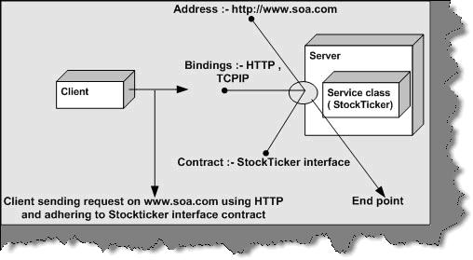
Figure 2: - Endpoint Architecture
Note: - You can also remember the end point by ABC where A stands for Address, B for bindings and C for Contract.
89) What are the important principles of SOA (Service oriented Architecture)?
Answer: -
WCF is based on SOA. All big companies are playing big bets on SOA. So how can Microsoft remain behind? So in order to implement SOA architecture easily you need to use WCF.
SOA is based on four important concepts:-
• Boundaries are well defined
In SOA, everything is formalized. The client who is consuming the service does not need to know how the implementation of the service is done. If you look at some old methodologies of communication like DCOM. Any changes at server level the client also has to change. Therefore, the server and client implementation was so much bound that changes need to be done at all places. In SOA, the rule is if you do enhancement you do not need to change anything at the client. SOA based application only understands that there is an end point, contract, and bindings.
Note: - Just to clarify shortly about end point and contract. Any SOA service is exposed through an end point. End point defines three important aspects What, Where and How. We will understand more details of the same in the later questions.
• Services evolve
Change is the law of nature and services will evolve. In SOA, services can be versioned and you can host those services in new ends. For instance, you have a service called as “Search Tickets (Ticket Number) “which gives details based on Ticket Number and its exposed on end point “ep1”. Tomorrow you want make your Search Tickets service more useful by also providing an extra option of allowing him to search by passenger name. Therefore, you just declare a new end “ep2” with service “Search Tickets (Ticket Number, Passenger Name)”. So the client who is consuming the service at end ep1 continues and at the other end, we have evolved our service by adding new ends ep2.
• Services share only schemas and contracts
Services use Schemas to represent data and contracts to understand behavior. They do not use language dependent types or classes in order to understand data and behavior. XML is used to define schemas and contracts. Due to this, there is not heavy coupling between environments.
• Service compatibility is policy based
Policy describes the capabilities of the system. Depending on policies, the service can degrade to match the service for the client. For instance your service needs to be hosted for two types of client one which uses Remoting as the communication methodology while other client uses DCOM. An ideal SOA service can cater to both of them according to there communication policies.
Note: - Many people assume Web services are the base for SOA. The answer is 50 % right. What web services lack is the policy based Service compatibility. If you host a web service it can only serve with HTTP communication channel and SOAP message. Any other type of client trying to communicate he will not degrade it self. This is what is provided by WCF. You can host the service in one or more mode. For instance you can host a WCF service using remoting and ASMX.
90) What is Windows Card Space?
Answer: -
It was previously known by its codename Info Card. It is a framework by Microsoft, which securely stores digital identities of a user and provides a unified interface to choose the identity for a particular transaction, such as logging in to a website. Windows Card Space is a central part of Microsoft’s effort to create an identity met system, or a unified, secure and interoperable identity layer for the internet.
91) What is .NET 3.0?
In one simple equation .NET 3.0 = .NET 2.0 + Windows Communication Foundation + Windows Presentation Foundation + Windows Workflow Foundation + Windows Card Space.
92) What is WCF?
Answer: -
First let us give a short answer to this: - “WCF (Indigo was the code name for WCF) is a unification of .NET framework communication technologies “.WCF is a unification technology, which unites the following technologies:-
• NET remoting
• MSMQ
• Web services
• COM+.
Below figure depicts WCF fundamentals pictorially.

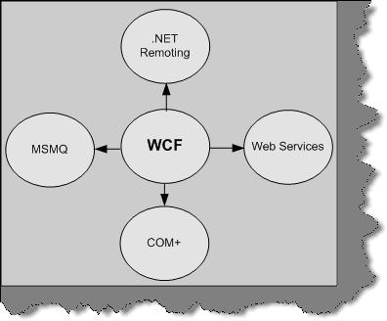

WCF Components

